Name: Sandesh Varma                                                              Date: 21/07/2025

Roll No: CH.EN.U4CSE22078

Experiment No: 3

__________________________________________________________________

Aim: To implement LL (1) parsing using C program.

Algorithm:

1. Read the input string.

2. Using predictive parsing table parse the given input using stack.

3. If stack [i] matches with token input string pop the token else shift it repeat the process until it reaches to $.

Code:

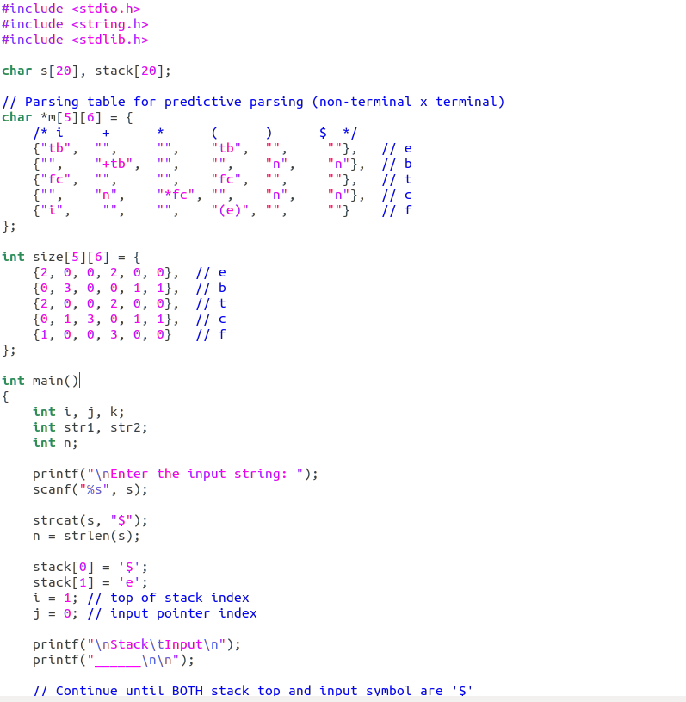

Sandesh Varma

CH.EN.U4CSE22078

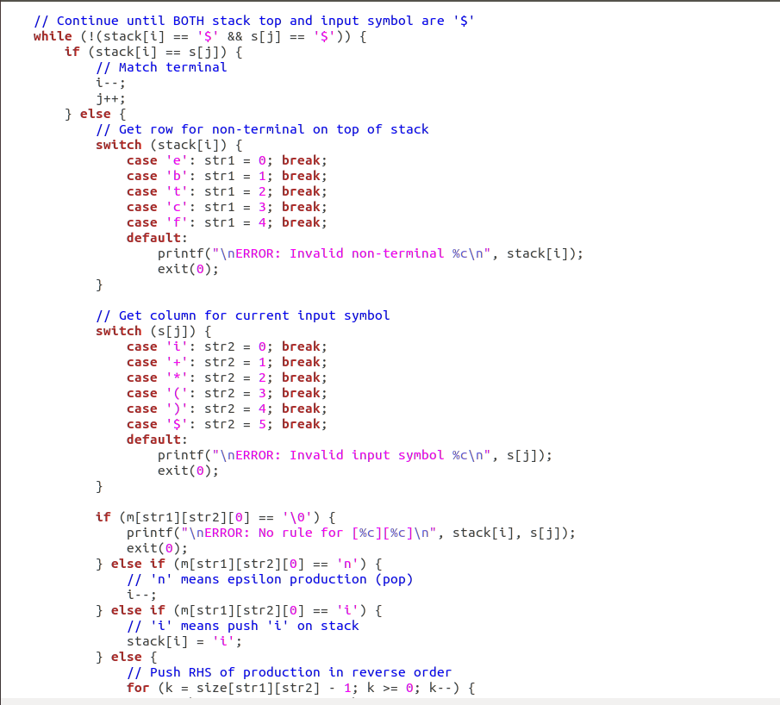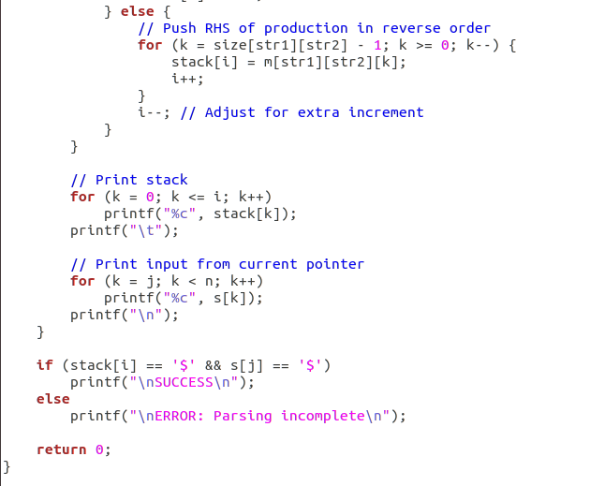

Sandesh Varma

CH.EN.U4CSE22078

Output:



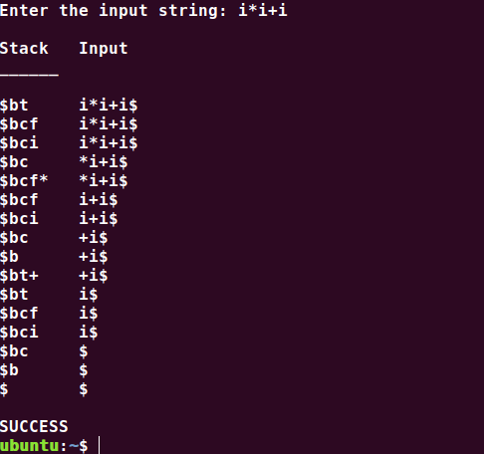

Results: The program to implement left factoring and left recursion has been successfully executed.